**OFFER LETTER**

**Date:22-04-2025**

**To   
Shaik Shajiya Sulthana**Hyderabad

**Welcome to Ozrit AI Solutions**

Dear Shajiya,

With reference to your interview with us dated 18th April, 2025, we are pleased to offer you the position as “**Business Development Executive**” as per the terms and conditions we discussed with you. If you agree to these terms, we would like you to join our Firm on or before **24th April,2025** or else the above offer will be null and void. After accepting the offer, please send us a copy of your resignation to the previous Organization duly received by them.

Your gross emoluments will be **Rs.1,80,000 per annum (CTC**). You will be issued a detailed appointment letter when you join us.

Please note that your appointment is subject to clear verification of your previous employment credentials, references, completion of academic program, physical fitness and submission of all the required documents. Your offer stands void and revoked with or without notice for any lawful reason.

**Required documents**

On the day of your joining you are required to submit the following:

(a) Certificates supporting your educational qualifications along with mark sheets

(b) Schooling certificate (SSC/ICSE) in support of your age or Birth Certificate

(c) Your latest 3 months salary slips or salary certificate.

(d) Your last 6 months Bank statement

(e) Your offer & relieving letter from your present & previous organizations.

(f) Service certificate from present & all previous employers

(g) Form 16 or taxable Income Statement duly certified by previous employer (Statement

showing deductions & taxable Income with break-up)

(h) 4 colored Passport size Photographs (with white background)

(i) Valid Passport details

(j) PAN card

**Note: If you have ever changed your name at any point in time, and for any reason whatsoever, please bring supporting documents for the same.**

**Employment terms and conditions**

1. Your appointment is contingent upon satisfactory reference & background checks, including verification of your application materials, education and employment history. Your employment is also contingent upon your ability to work for the Firm without restriction (i.e. you do not have any non-compete obligations or other restrictive clauses with any previous employer).

2. Your designation may be changed at the discretion of the Firm depending on the work assigned to you and the requirement/business needs of the Firm.

3. Your employment with the Firm is at-will. If you are separating voluntarily, you are required to serve notice period of 60 days, failure to give you the requisite notice two months salary has to be paid to the Firm . Irrespective of any changes during your employment at the Firm, this at-will relationship is not intended to change, except when in a client facing assignment. At any stage of your employment with the Firm, if you are working on a client facing assignment or if you are in a role which requires knowledge transfer necessarily, you shall be required to conduct knowledge transfer before being relieved. While working on a client facing assignment, you or the Firm may terminate your service at any time by giving 60 days of notice or one months’ basic salary in lieu thereof except in some circumstances, based on the need and the client concerned, the Firm may require you to serve a period of 90 days for transition.

4. Upon your resignation, you are required to return all Firm’s assets and property back to the relevant person(s)/department(s).

5. Your remuneration shall remain confidential and is to be strictly kept between yourself and the Firm. You should be aware that your compensation is determined based on numerous

factors such as your job, skills, specific background, and professional merit. This information and any changes made therein should be treated as personal and confidential.

6. During your service with the Firm you are expected to devote your time and attention to the Firm’s affairs and refrain from directly or indirectly engaging in any other business.

7. Any Information pertaining to Firm operations is to be treated as intellectual property and is bound by a confidentiality and a non-disclosure clause of your terms of employment. If you are

bound by a confidentiality agreement with a previous employer, you must notify the Firm and indemnify the Firm against any breach thereof.

8. If any information furnished to the Firm in pursuance to your application for employment or during the selection process is found at any time to be incorrect or false, and/or if you have suppressed material information regarding your qualifications and experience, the Firm may terminate your services without any notice or compensation.

9. You shall abide by all the rules and regulations of the Firm which are in force from time to time and the Firm shall have the right to vary or modify any or all of the above terms and conditions which shall be binding on you. The impact of today's technology and pace of change is tremendous. We hope you're as excited as we are to play a part in that revolution. To confirm your acceptance of this offer letter on the terms and conditions specified herein, please acknowledge your acceptance.

**Best Regards**

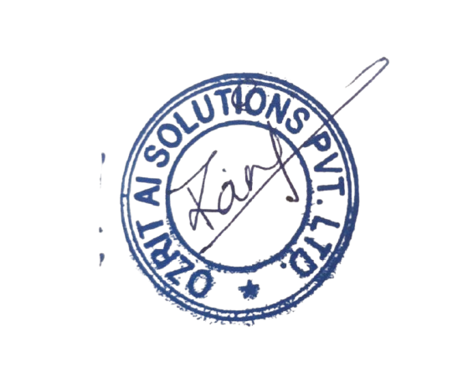

**Rani Kumari**

**HR & Admin Executive**

**COMPENSATION STRUCTURE**

| **Salary Breakup** |  |  |
| --- | --- | --- |
| **Name : Shajiya** |  |  |
| **Designation : Business development Executive** |  |  |
| **Date of Joining : 24-04-2025** |  |  |
|  |  |  |
| **Gross** | **Monthly** | **Annually** |
| Basic salary | 6,000 | 72,000 |
| HRA | 2,400 | 28,800 |
| Special allowance | 2,810 | 33,720 |
| Conveyance | 1600 | 19,200 |
| EPF | 1,440 | 17,280 |
| Professional Tax | 150 | 1800 |
| ESI | 600 | 7,200 |
| **Gross Salary** | **15,000** | **1,80,000** |
| **NET SALARY** | **12,810** | **1,53,720** |